**Superstore Analysis**

**Visualization link:** [Tableau visualisation](https://public.tableau.com/shared/FHB5Z7RCZ?:display_count=n&:origin=viz_share_link)   **Tools used:**

**Dataset:** [Superstore Data](https://d1rzmu666mzzrt.cloudfront.net/public_assets/assets/000/002/772/original/sample_-_superstore.xls?1655548436)

**Problem statement:** Identify the root causes of financial losses in specific regions and product categories within the Superstore, with a focus on understanding and mitigating the negative impact on profitability.

**Workflow:**

* Dashboard 1: Find out which state is losing money and get an overall summary.
* Dashboard 2: Find the City and the subcategory where it is losing money.
* Dashboard 3: For the selected city and subcategory, find why it is losing money.

**Dashboard 1:**

* Find out which state is losing money and get an overall summary
  + Show overall summary for the profit and sales value as text
  + Show state wise profit and sales in single map (<https://youtu.be/x-k6PYernug>)
  + Display sales and profit for each subcategory using heat map
  + Have an Order date filter through which we can select year and the visualization will be updated based on the year selected

**Sheet1** - Overall summary of Profit and sales for US.

* Drag measure names to columns
* Drag measure values to text in marks card
* From measure values card remove all measures except sales and profit
* Change fit to entire view
* Drag measure names to text in marks card
* Click on text in the Marks card, open the dialog box, change size of ‘measure values’ to 16.
* Click on text, change horizontal alignment to centre.
* Right click on header, uncheck ‘show header’ option.



* Rename the sheet as summary

**Sheet 2** - State wise profit and sales using map visualization.

* Drag longitude to columns
* Drag latitude to rows
* Drag state to detail in marks card
* Click on the ‘49 unknown’ box in the bottom right corner.
* Click edit locations, change country/region to from field > country. Click OK.
* Change chart type to map
* Drag Sales to color in marks card
* Drag latitude to rows shelf to get 2 graphs

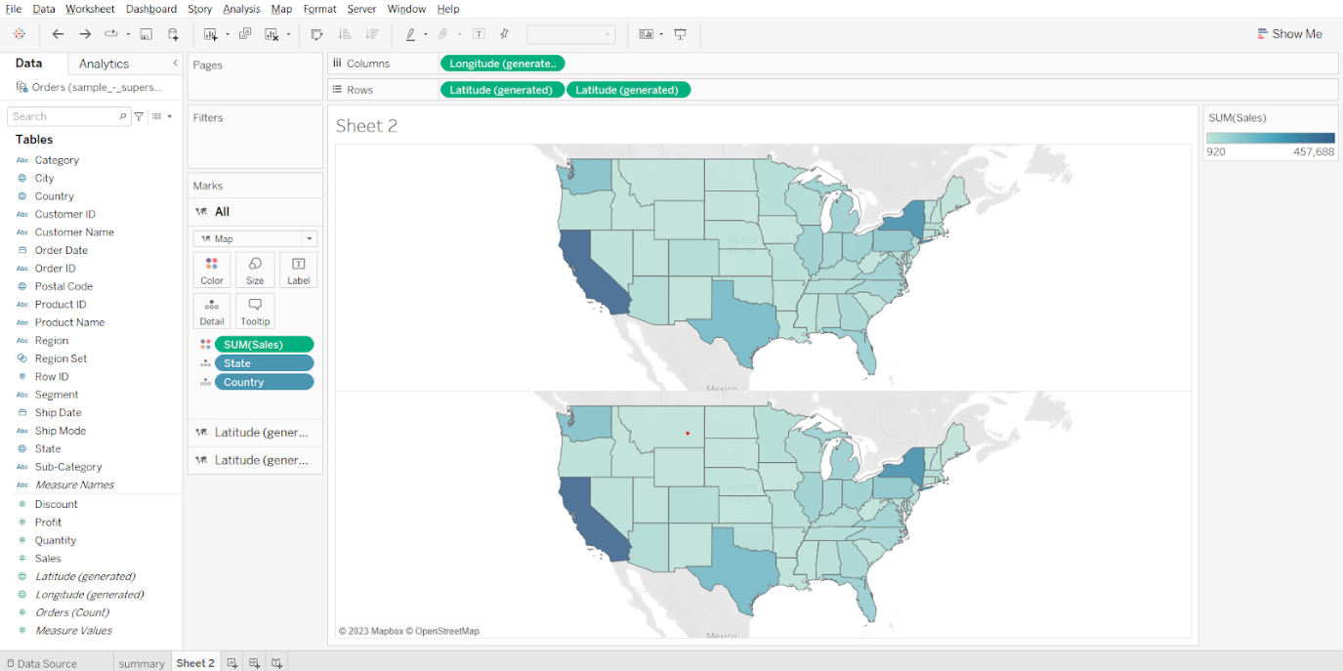

* Click on the second Latitude chart in the marks card.
* Remove sales, drop profit on size.
* Change mark type to circles.
* Click on colour and choose black.
* Click on size and adjust the size of the circles.
* Open the latitude dropdown in the rows shelf and choose ‘Dual Axis’.

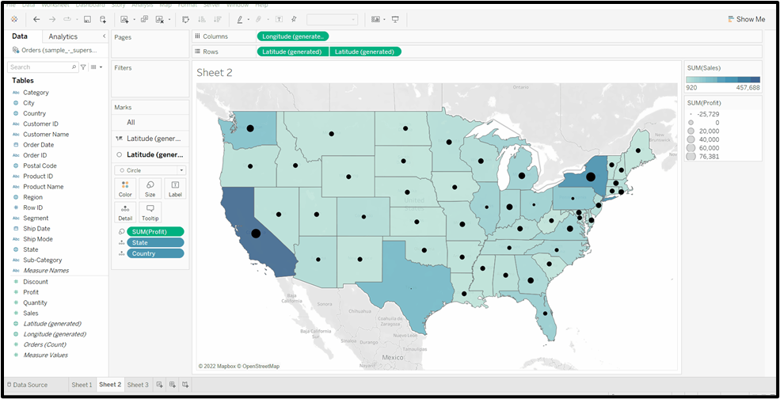

From the plot we can see that Texas has the lowest profit compared to the rest of the states.

Adding a filter for order date:

* Drag order date to filter card, select year, click next, select ‘use all’, click OK.



**Sheet 3** - Subcategory wise profit and sales.

* Drag category and sub-category to rows, drop sales on colour, profit on size, adjust size as per need.
* Change fit to entire view, right click on header in sheet, remove header labels.



From the above dashboard we can see that for the state of Texas we have negative profit and for subcategory we have the negative profit so let’s analyse further why this is so.

Adding order date filter for the dashboard:

* Create a new dashboard, set size to automatic, drop all 3 sheets on the canvas as shown in the screenshot below, open sheet 2 menu (from top right corner of sheet 2 container), select filters > year of order date.
* Right click on the filter and choose a single value slider. Open the menu from the filter container, select Apply to worksheets > All using this data source.



Note: Keep the Order date filter field to All for further analysis.

* Selecting State-Texas and Subcategory-Table and profit field for further analysis

**Sheet 4** - Plotting city wise profit for the state of Texas.

* Drag state to filter, select Texas, click OK. Drag city to rows, profit to columns, profit to colour. Change fit to the entire view.



We can see that the city Houston is where we are losing more money.

Showing city interactive filter:

* Open the State menu in the filter card, choose show filter.
* Convert the checklist into a single value dropdown.



**Sheet 5** -

* Drag subcategory to rows, profit to columns. Drag state to filters, select Texas, click ok.
* From the State dropdown in filters, add it to context. Drag city to filters, from dropdown select show filter, convert the checklist to a single value dropdown. Drag Profit to colour.
* From city dropdown select Houston.

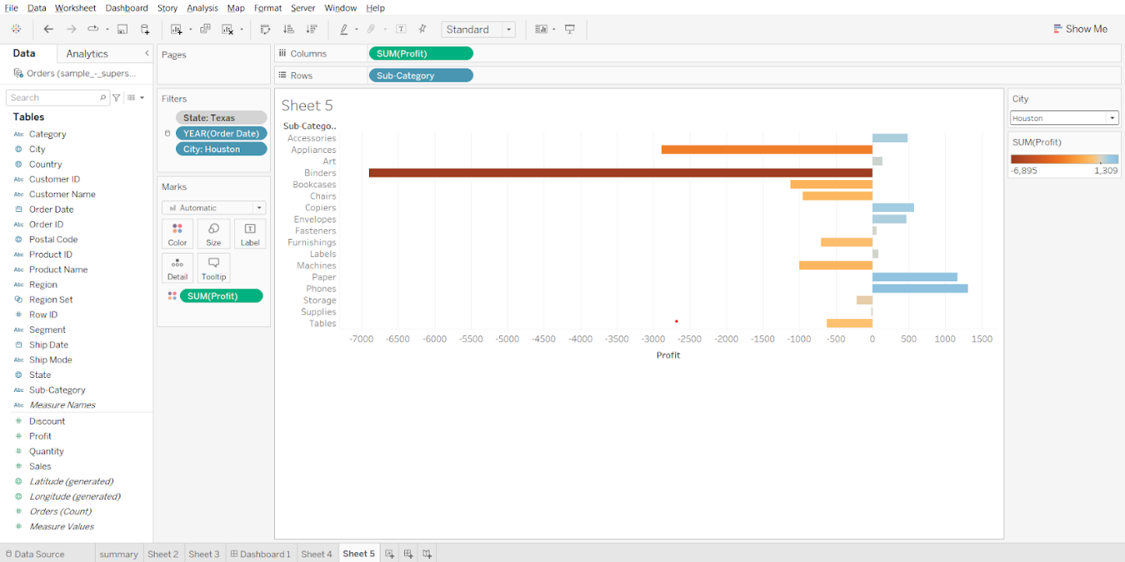

We can see that for city Houston we are losing more money in subcategory binders.

Creating a dashboard:

* Create a new dashboard, set size to automatic, drop sheet 4 and sheet 5 on the canvas. Hide title for both sheets.



So, we can see that for the state of Texas in the city of Houston we are losing money in subcategory binder so let’s further analyse exactly which product we are losing money in.

**Sheet 6** - Creating products wise profit for city Houston and subcategory binders.

* Drag product name to rows, add all members. Drag profit to columns, drag city to filters, select Houston, click OK.
* Drag subcategory to filters, select binders, click OK. Drag profit to colour, change fit to Entire View.

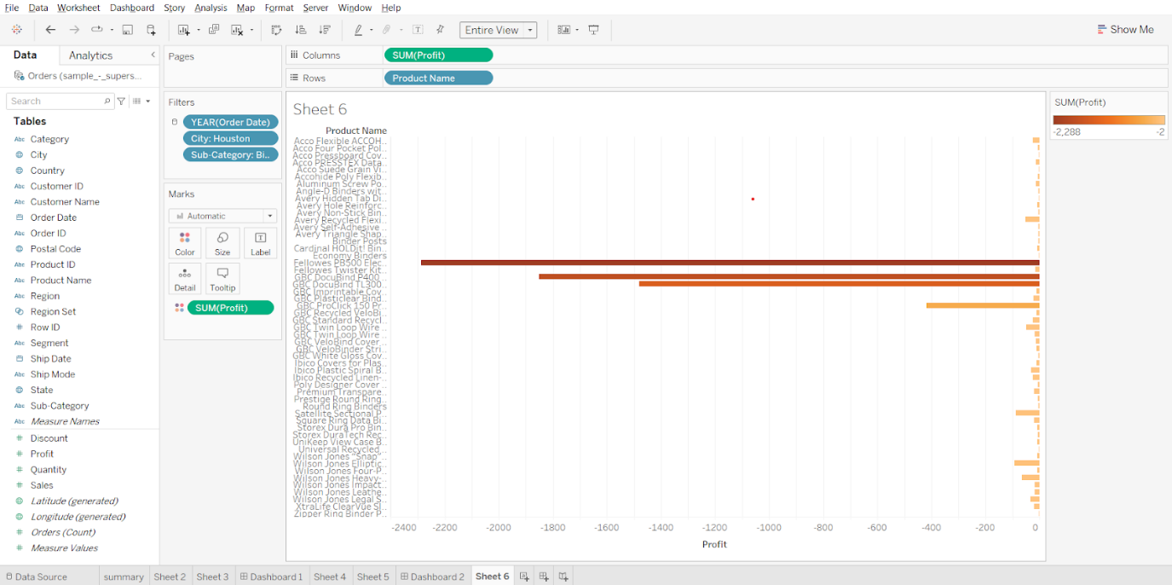

So, we can see that within binders there are 3 products where we are losing more money, mainly there are binding machines. Let’s analyse why that is so.

**Sheet 7** - Plotting average discount vs profit for each product within subcategory binder and for city Houston.

* Duplicate sheet 6, rename it as Sheet 7, drag discount to columns before profit. Change its measure to average.
* From discount marks cards, remove profit from colour.



So, we can see that for city Houston and for subcategory binders all the products have an average discount of 0.8 or 80% on them which is why the store in Houston is losing more money in Houston city.

Creating a story for above analysis:

The 1st tab is the sales and profit summary for the US.

* Create a new story, add dashboard 1 to the canvas, set size to automatic, write ‘Summary’ in caption



The 2nd tab is analysing what went wrong in Texas.  
So we can see that for city Houston and for the binder subcategory we are losing money.

* Creak a new story point, write ‘What went wrong in Texas’ as caption, drag dashboard 2 to the canvas.



The 3rd tab we are diving deeper to find for which products are we losing money for Houston city and Binders category.

* Create a new story point, type ‘Product wise analysis’ in caption, drag sheet 6 to the canvas.



We can see that almost all the products that come under the Binder category are losing money.  
So let see why is that so?

* Create a new story point, type ‘Why so?’ in the caption and drag sheet 7 to the canvas.



So, we can see that for all the products that are there in subcategory binder and for city Houston it is giving an average discount of 0.8 or 80% which is why it is losing more money compared to other subcategories.

To publish the workbook, press Ctrl + S, sign in, name the workbook.



**Interference (Insights and Conclusions)**

1. **Summary:** Identifying the State with Losses

- Insight: Texas stands out as the state experiencing the most significant financial losses when evaluating profit margins across all states.

2. **What Went Wrong in Texas:** City and Subcategory Analysis

- Insight: Within Texas, the city of Houston is where the losses are concentrated, particularly in the subcategory of binders.

3. **Product Analysis:** Evaluation of Products Under Binder Subcategory

- Insight: A detailed analysis reveals that every product in the binder subcategory is contributing to the financial losses in Houston.

4. **Why So?** Understanding the Cause of Losses

- Insight: The primary reason for the losses in the binder subcategory in Houston is the high average discount of 80% being applied to these products. This substantial discount significantly impacts the profit margins, leading to the observed financial losses.

**Conclusion:**

The analysis highlights that Texas, particularly Houston, is facing financial losses due to the binder subcategory. The root cause of these losses is the steep discounting of binder products, which reduces profit margins drastically. Addressing the discount strategy for binders in Houston could potentially mitigate these losses and improve the overall financial health of the store in this region.

**Recommendations:**

1. **Review and Adjust Discount Strategy**

- Action: Conduct a comprehensive review of the discount policies for binder products in Houston.

- Recommendation: Reduce the average discount rate from the current 80% to a more sustainable level. Analyze the impact of various discount rates on sales volume and profit margins to find an optimal balance.

2. **Targeted Marketing Campaigns**

- Action: Develop targeted marketing campaigns to boost the sales of binder products without relying heavily on discounts.

- Recommendation: Use promotional tactics such as bundling binders with other high-margin products or offering limited-time offers that incentivize purchases without eroding profit margins.

3. **Optimize Inventory Management**

- Action: Implement more effective inventory management practices for binder products.

- Recommendation: Utilize data analytics to forecast demand more accurately and adjust inventory levels accordingly, reducing the need for excessive discounting to clear out overstocked items.

4. **Product Diversification**

- Action: Expand the product range within the binders subcategory to include higher-margin items.

- Recommendation: Introduce premium binder products with added features that justify a higher price point, thereby improving overall profit margins for the subcategory.

5. **Customer Feedback and Engagement**

- Action: Gather customer feedback on binder products and their pricing.

- Recommendation: Use surveys and focus groups to understand customer perceptions of binder value and pricing. Adjust pricing strategies based on this feedback to align with customer expectations while maintaining profitability.

6. **Sales Training**

- Action: Provide additional training for sales staff in Houston to better understand and promote binder products.

- Recommendation: Equip sales teams with the knowledge and tools to highlight the value and benefits of binders, thereby reducing reliance on discounts to close sales.

7. **Monitor and Adjust**

- Action: Continuously monitor the impact of implemented changes on sales and profitability.

- Recommendation: Set up a dashboard to track key performance indicators (KPIs) related to binder sales, discounts, and profit margins. Make data-driven adjustments as necessary to ensure ongoing financial health.

Implementing these recommendations will help mitigate losses in the binder subcategory in Houston and improve overall profitability for the Superstore.